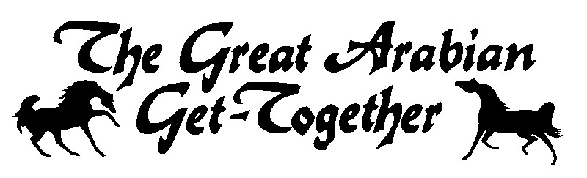 Great Arabian Get-Together
June 25-26, 2026
Simons Arena Cannon Falls, MN

 | Horse’s Name |  |  |  |  |  |  |  |  |  |  |  | Reg. No. |  |  |  |  |  |  |  | DOB MM/DD/YY | Sex | Color |  | Sweepstakes  Yes No
 | Sire |  |  |  |  |  |  |  | Dam |  |  |  |  |  |  |  | Horse USEF ID# |  |  |  |  | Horse USDF #
Rider 1 | Classes / Sections |  |  |  |  |  |  |  |  |  |  |  |  |  |  |  |  |  |  |  |  |  |  | TOTAL FEES
Rider 1 | Entry Fees |  |  |  |  |  |  |  |  |  |  |  |  |  |  |  |  |  |  |  |  |  |  | $
Name |  |  |  |  |  |  |  |  |  | DOB MM/DD/YY |  |  |  | Amateur Certificate  Yes No |  |  |  | Rider’s Relationship to horse owner(s) for owner classes
AHA# |  |  |  |  |  | USEF/EC# |  |  |  |  |  |  |  | USDF# |  |  |  |  |  |  |  | US Citizen: Yes No
Address |  |  |  |  |  |  |  |  |  | City |  |  |  |  |  |  |  |  | State |  |  | Zip
Rider 2 | Classes / Sections |  |  |  |  |  |  |  |  |  |  |  |  |  |  |  |  |  |  |  |  |  |  | TOTAL FEES
Rider 2 | Entry Fees |  |  |  |  |  |  |  |  |  |  |  |  |  |  |  |  |  |  |  |  |  |  | $
Name |  |  |  |  |  |  |  |  |  | DOB MM/DD/YY |  |  |  | Amateur Certificate  Yes No |  |  |  | Rider’s Relationship to horse owner(s) for owner classes
AHA# |  |  |  |  |  | USEF/EC# |  |  |  |  |  |  |  | USDF# |  |  |  |  |  |  |  | US Citizen: Yes No
Address |  |  |  |  |  |  |  |  |  | City |  |  |  |  |  |  |  |  | State |  |  | Zip
Rider 3 | Classes / Sections |  |  |  |  |  |  |  |  |  |  |  |  |  |  |  |  |  |  |  |  |  |  | TOTAL FEES
Rider 3 | Entry Fees |  |  |  |  |  |  |  |  |  |  |  |  |  |  |  |  |  |  |  |  |  |  | $
Name |  |  |  |  |  |  |  |  |  | DOB MM/DD/YY |  |  |  | Amateur Certificate  Yes No |  |  |  | Rider’s Relationship to horse owner(s) for owner classes
AHA# |  |  |  |  |  | USEF/EC# |  |  |  |  |  |  |  | USDF# |  |  |  |  |  |  |  | US Citizen: Yes No
Address |  |  |  |  |  |  |  |  |  | City |  |  |  |  |  |  |  |  | State |  |  | Zip

Each person signing this entry form acknowledges that he/she has read the front and reverse of this Entry Form and agrees to the applicable terms, conditions, waivers
Minor entrants must also have parent/guardian signature(s) on the back., releases, indemnification and consent as set forth herein. Each person agrees that the information is accurate to the best of his/her knowledge.

Total Entry Fees $

Office Fee (per horse) @ $23 $
AHA Resolution 9-90 per horse @ $5. $
AHA Recording Fee per horse @ $7 $
Box Stalls @ $50 per night
No initial bedding
Tack Stalls @ $55/N or$100/show $
Shavings @ $12 $
Member/Single Event Fees:
AHA Single Event Fee @ $40 per person $
Other Fees
Camping @ $ 65/N $
Misc $
Mics $
Misc $

TOTAL FEES DUE $

Office use
Check or CC auth
Total
Due/Refund
Post Mark Date

THE FOLLOWING MUST BE SENT WITH YOUR ENTRIES
Photo copies of AHA, USEF/EC, Membership cards for each Rider/Driver/Handler/Coach/Trainer/Owner,
Horses Registation papers & Purchase contract if applicable.

OWNER INFORMATION Owner name as it appears on registration papers/purchase contract
Name
If Joint owner check one:_____Non Related Co Owner Related – What is the Relationship?
AHA# USEF/EC# USDF#
Farm/Ranch USEF Farm ID#
Current Address Phone
City ST Zip
Email
TRAINER INFORMATION (must be filled out, if there is no trainer, the person responsible for the horse at the show)
Name
AHA# USEF/EC#
Address Phone
City ST Zip
Email
ADDITIONAL INFORMATION Camper Plate # Camper make
Send Acknowledgement to Owner Trainer Both
Email Acknowledgement to (Print)
Stable with

ENTRIES CLOSE – June 8 Make Checks payable to MHAHA
Mail to: Leesa Berhow
N12861 190th St
Boyceville, WI 54725
lrberhowhss@gmail.com

ALL ENTRY FORMS MUST BE PROPERLY SIGNED BACK SIDE
AHA ENTRY AGREEMENT
I have read the rules concerning competitions as printed in the Arabian Horse Association (AHA) Handbook/Directory and Competition Prize List and agree to be bound by and subject to those rules.
AHA ASSUMPTION OF RISK, RELEASE AND INDEMNIFICATION This document waives very important legal rights. Read it carefully before signing.
In consideration for AHA permitting me to participate in this Competition, and by signing the entry blank, I agree as follows:
I AGREE that I choose to participate voluntarily in this Competition as a rider, driver, handler, lessee, owner, agent, coach, trainer, junior exhibitor or as a parent or guardian of a junior exhibitor. I AM FULLY AWARE AND ACKNOWEDGE THAT HORSE SPORTS AND PARTICIPATION IN THIS COMPETITION INVOLVE SERIOUS RISK OF HARM INCLUDING, BUT NOT LIMITED TO, RISKS OF ACCIDENT, SERIOUS BODILY INJURY, INCLUDING DEATH, BROKEN BONES, HEAD INJURIES, TRAUMA, PAIN, AND SUFFERING, AND PROPERTY DAMAGE. I ASSUME ALL RISK OF HARM TO ME, MY HORSE OR MY PROPERTY.
I AGREE as a Horse Show Participant (or Parent/Guardian of Participant if a minor) to waive all claims which may otherwise arise from, including but not limited to infectious bacteria, viruses, fungi mold, parasites or other agents with may be present at the Horse Show (and most other outdoor locations) and can cause infection in humans, as well as animals.
I AGREE for myself, my heirs, executors, administrators, successors and assigns to release AHA, The Competition, the facilities leased by the Competition and the owner(s) of the facilities,and all of their respective officers, officials, directors, employees, agents, personnel, volunteers, affiliated organizations and insurers collectively, the “released Parties”, from any and all claims for damage, loss, or injury to myself, other persons, horses or other property belonging to me to the fullest extend permitted by law that arises out of or relates in any way to the Competition and my participation in the Competition INCLUDING, BUT NOT LIMITED TO, DAMAGES, LOSS, OR INJURY RESULTING FROM ANY ACTS, FAILURE TO ACT, MEGLIGENCE OR NEGLECT OF OTHER ENTRANTS, THE RELEASED PARTIES, THEIR CONTRACOTRS OR INVITEES, as well as for theft, vandalism, fire, other casualty damage or damage arising out of any defects in the premises.
I AGREE to indemnify and hold harmless (that is pay all losses, damages, attorneys fees) of whatsoever kind and nature, which may be asserted against or incurred by any of them as a result of (1) my participation in the Competition or (2) any act, failure to act, or neglect (a) by me, my agents, employees, riders, handlers, trainers, coaches, drivers, contractors or invitees, or (b) by any animal owned or exhibited by me or in my custody or control.
I AGREE and represent that I am qualified and eligible to enter and/or participate in the Competition, and every horse I am entering is qualified and eligible as entered.
I AGREE to accept AS FINAL any decision of AHA, the Show Commission or Show Officials concerning my qualification or the qualification of my horse to enter the Competition or any results of the Competition, except to the extent that the Rules of AHA, the Competition, EC or USEF Equestrian permit a protest or hearing of such decisions. Should a hearing be requested, I agree to accept AS FINAL the decision of the particular hearing body. I agree to release, hold harmless and not to sue AHA., the Competition Sponsor, their officers, directors, employees, volunteers or members concerning any decision of AHA, the Compeition, its Show Commission, Show Officials or any hearing body that relates to my qualifications or my horses(s)’ qualifications to enter the Competition or any results of the Competition.
I AGREE that AHA has the sole right to control, sell, supervise or give away (or assign to others the right to do so) the exclusive rights to broadcast, televise, reproduce, transmit and disseminate all or part of this event, and I agree that AHA may use or assign, in any way AHA sees fit, photographs, films, videos, audios, cablecasts, or other likenesses of me and my horse taken during the course of the Competition for the promotion, coverage or benefit of the Competition or AHA. Those likenesses shall not be used to advertise a product and they may not be used in such a way which implies endorsement of any company, product, product category or service. I hereby expressly and irrevocably waive and release any rights in connection with such use, including any claim to compensation, invasion of privacy, right of publicity, or to misappropriation.
By signing below as a parent or guardian of a junior exhibitor, I consent to the child’s participation and agree to all of the above provisisons, and further agree to assume all of the obligations of this AHA Assumption of Risk, Release and Indemnification personally and on behalf of the child.
This AHA Assumption of Risk, Release and Indemnification is governed by the Laws of the State of Colorado and is intended to be interpreted as broadly as possible. I agree that exclusive jurisdiction and venue (place) for any legal action against AHA, its officers, directors, employees, volunteers or agents shall be in the local district courts or the federal court of the State of Colorado. If any part of this agreement is determined to be unenforceable, all other parts shall remain in effect.
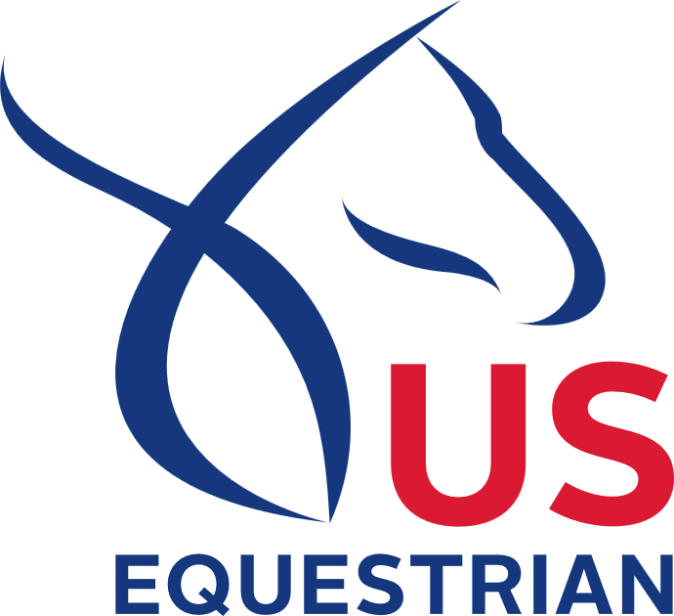
FEDERATION ENTRY AGREEMENT
By entering a Federation-licensed Competition and signing this entry blank as the Owner, Lessee, Trainer, Manager, Agent, Coach, Driver, Rider, Handler, Vaulter or Longeur and on behalf of myself and my principals, representatives, employees and agents, I agree that I am subject to the Bylaws and Rules of the United States Equestrian Federation, Inc. (the “Federation”) and the local rules of MAHA Spring Fling (Competition). I agree to be bound by the Bylaws and Rules of the Federation and of the competition. I will accept as final the decision of the Hearing Committee on any question arising under the Rules, and agree to release and hold harmless the competition, the Federation, their officials, directors and employees for any action taken under the Rules. I represent that I am eligible to enter and/or participate under the Rules, and every horse I am entering is eligible as entered. I also agree that as a condition of and in consideration of acceptance of entry, the Federation and/or the Competition may use or assign photographs, videos, audios, cable-casts, broadcasts, internet, film, new media or other likenesses of me and my horse taken during the course of the competition for the promotion, coverage or benefit of the competition, sport, or the Federation. Those likenesses shall not be used to advertise a product and they may not be used in such a way as to jeopardize amateur status. I hereby expressly and irrevocably waive and release any rights in connection with such use, including any claim to compensation, invasion of privacy, right of publicity, or to misappropriation. The construction and application of Federation rules are governed by the laws of the State of New York, and any action instituted against the Federation must be filed in New York State. See GR908.4.
If not currently a USEF Active Competing member or Subscriber, I acknowledge that I will be enrolled for no cost as a USEF Fan and my USEF Fan Account will continue to annually automatically renew in USEF’s sole discretion. Additionally, I acknowledge that the benefits of a USEF Fan are subject to change without notice. USEF may in its sole discretion, at any time, terminate my USEF Fan status.
BY SIGNING BELOW, I AGREE that I have read, understand, and agree to be bound by all applicable Federation Bylaws, rules, and policies including the USEF Safe Sport Policy and Minor Athlete Abuse Prevention Policies (MAAPP) as published at www.usef.org, as amended from time to time, as well as all terms and provisions of this Prize List. If I am signing and submitting this Agreement electronically, I acknowledge that my electronic signature shall have the validity, force and effect as if I affixed my signature by my own hand.
Must be signed in at least 3 places by Adults Only!!
Owner **Mandatory | Print Name | Signature
Trainer or custodian of horse at show | Print Name | Signature
Rider A **Mandatory | Print Name | Signature
Rider B **Mandatory | Print Name | Signature
Rider C **Mandatory | Print Name | Signature
Minor name (Print) | Print parent or guardian Name | Adult Signature
Minor name (Print) | Print parent or guardian Name | Adult Signature
**Emergency phone #
AHA or USEF/EC membership is not required for Parents/Guardians signing for minors.

