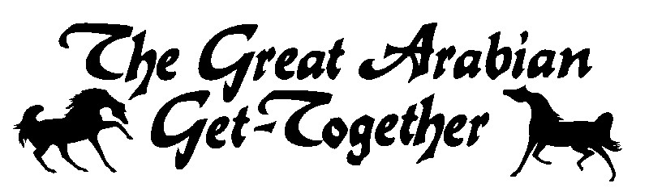 Great Arabian Get-Together
June 19-20, 2025
Double F Arena – Hinckley, MN

 | Horse’s Name |  |  |  |  |  |  |  |  |  |  |  | Reg. No. |  |  |  |  |  |  |  | DOB MM/DD/YY | Sex | Color |  | Sweepstakes  Yes No
 | Sire |  |  |  |  |  |  |  | Dam |  |  |  |  |  |  |  | Horse USEF ID# |  |  |  |  | Horse USDF #
Rider 1 | Classes / Sections |  |  |  |  |  |  |  |  |  |  |  |  |  |  |  |  |  |  |  |  |  |  | TOTAL FEES
 | Entry Fees |  |  |  |  |  |  |  |  |  |  |  |  |  |  |  |  |  |  |  |  |  |  | $
Name |  |  |  |  |  |  |  |  |  | DOB MM/DD/YY |  |  |  | Amateur Certificate  Yes No |  |  |  | Rider’s Relationship to horse owner(s) for owner classes
AHA# |  |  |  |  |  | USEF/EC# |  |  |  |  |  |  |  | USDF# |  |  |  |  |  |  |  | US Citizen: Yes No
Address |  |  |  |  |  |  |  |  |  | City |  |  |  |  |  |  |  |  | State |  |  | Zip
Rider 2 | Classes / Sections |  |  |  |  |  |  |  |  |  |  |  |  |  |  |  |  |  |  |  |  |  |  | TOTAL FEES
 | Entry Fees |  |  |  |  |  |  |  |  |  |  |  |  |  |  |  |  |  |  |  |  |  |  | $
Name |  |  |  |  |  |  |  |  |  | DOB MM/DD/YY |  |  |  | Amateur Certificate  Yes No |  |  |  | Rider’s Relationship to horse owner(s) for owner classes
AHA# |  |  |  |  |  | USEF/EC# |  |  |  |  |  |  |  | USDF# |  |  |  |  |  |  |  | US Citizen: Yes No
Address |  |  |  |  |  |  |  |  |  | City |  |  |  |  |  |  |  |  | State |  |  | Zip
Rider 3 | Classes / Sections |  |  |  |  |  |  |  |  |  |  |  |  |  |  |  |  |  |  |  |  |  |  | TOTAL FEES
 | Entry Fees |  |  |  |  |  |  |  |  |  |  |  |  |  |  |  |  |  |  |  |  |  |  | $
Name |  |  |  |  |  |  |  |  |  | DOB MM/DD/YY |  |  |  | Amateur Certificate  Yes No |  |  |  | Rider’s Relationship to horse owner(s) for owner classes
AHA# |  |  |  |  |  | USEF/EC# |  |  |  |  |  |  |  | USDF# |  |  |  |  |  |  |  | US Citizen: Yes No
Address |  |  |  |  |  |  |  |  |  | City |  |  |  |  |  |  |  |  | State |  |  | Zip

Each person signing this entry form acknowledges that he/she has read the front and reverse of this Entry Form and agrees to the applicable terms, conditions, waivers
Minor entrants must also have parent/guardian signature(s) on the back., releases, indemnification and consent as set forth herein. Each person agrees that the information is accurate to the best of his/her knowledge.

Total Entry Fees $

Office Fee (per horse) @ $23 $
AHA Resolution 9-90 per horse @ $5. $
AHA Recording Fee per horse @ $7 $
Box Stalls @ $50 per night
No initial bedding
Tack Stalls @ $55/N or$100/show $
Shavings @ $12 $
Member/Single Event Fees:
AHA Single Event Fee @ $40 per person $
Other Fees
Camping @ $ 100/site $
Misc $
Mics $
Misc $

TOTAL FEES DUE $

Office use
Check or CC auth
Total
Due/Refund
Post Mark Date

THE FOLLOWING MUST BE SENT WITH YOUR ENTRIES
Photo copies of AHA, USEF/EC, Membership cards for each Rider/Driver/Handler/Coach/Trainer/Owner,
Horses Registation papers & Purchase contract if applicable.

OWNER INFORMATION Owner name as it appears on registration papers/purchase contract
Name
If Joint owner check one:_____Non Related Co Owner Related – What is the Relationship?
AHA# USEF/EC# USDF#
Farm/Ranch USEF Farm ID#
Current Address Phone
City ST Zip
Email
TRAINER INFORMATION (must be filled out, if there is no trainer, the person responsible for the horse at the show)
Name
AHA# USEF/EC#
Address Phone
City ST Zip
Email
ADDITIONAL INFORMATION Camper Plate # Camper make
Send Acknowledgement to Owner Trainer Both
Email Acknowledgement to (Print)
Stable with

ENTRIES CLOSE – June 8 Make Checks payable to MHAHA
Mail to: Leesa Berhow
N12861 190th St
Boyceville, WI 54725
lrberhowhss@gmail.com

ALL ENTRY FORMS MUST BE PROPERLY SIGNED BACK SIDE

