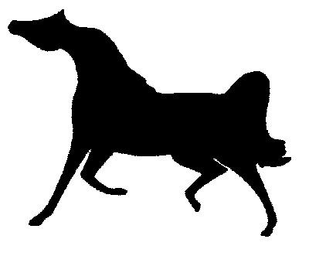
The Great Arabian Get – Together V Show
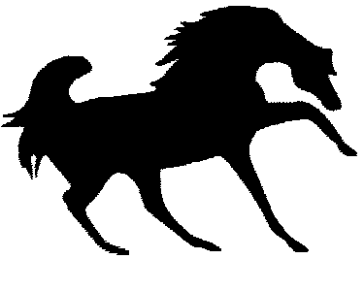

June 25-26, 2026
**********

simons Arena
cannon falls, Minnesota
**********

MN Half Arabian Horse Association
**********

Region 10 Value Show
**********
Pre—Entries Close June 14, 2026
**********

APPROVED BY:

Arabian Horse Association
Tri-State Horsemen's Association
Western Dressage Association

ORIGINAL NEGATIVE COGGINS REQUIRED

Become a Show Patron!!
See information on Sponsorship Form

AHA V-Show #: 251016377

AHASM Value Show Number
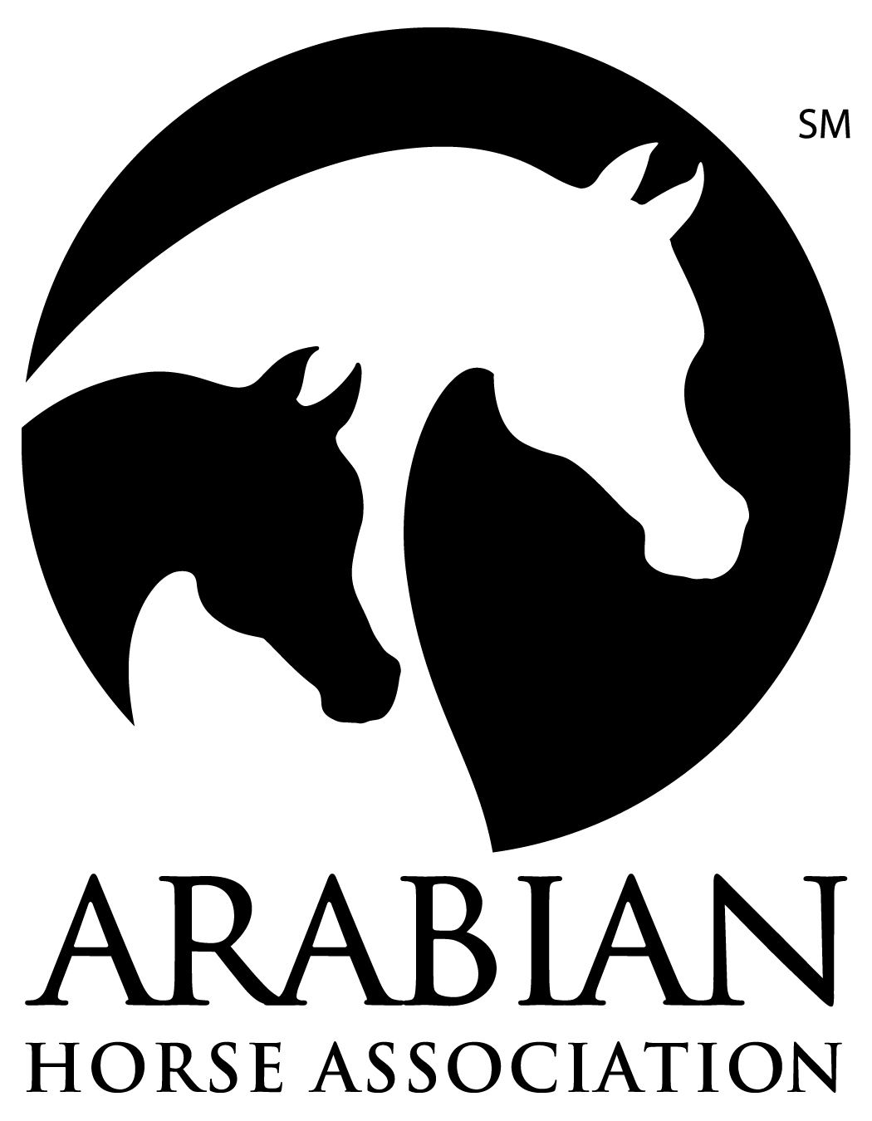
261016745

THE ARABIAN HORSE ASSOCIATIONSM
RECOGNIZES THE ARABIAN DIVISION OF THIS SHOW

Sponsored By The Arabian Horse Association

The Arabian Horse Association is a major equine association serving members in the United States and Canada. It registers and maintains a database of more than one million Arabian, Half-Arabian and Anglo- Arabian horses and administers more than $2.5 million in annual prize money. AHA produces championship events, recognizes over 375 Arabian horse shows and distance rides annually and provides activities and programs that promote breeding and ownership. For information about Arabian, Half-Arabian and Anglo-Arabian horses, call 303-696-4500, e-mail info@ArabianHorses.org or visit ArabianHorses.org

All Arabian/Half-Arabian/Anglo-Arabian exhibitors entered in this event must be a current AHA member with a Competition Card or pay a Single Event Membership fee per person. This includes any owner, trainer, driver, rider, or halter handler who exhibits horses in the show ring or signs the entry form as the responsible person for any individual's horse.

To join the Minnesota Half-Arabian Horse Association.

please contact Michelle Wiberg Michelle.wiberg.dvm@gmail.com
Contributions or gifts to AHA are not tax deductible as charitable contributions. However, they may be deductible as ordinary and necessary business expenses if so advised by appropriate tax counsel.
Join AHA through your local club for the following great member benefits:
- Reduced rate for competition privileges across a variety of disciplines for local, regional and national AHA-approved shows and rides
- Peace of mind with 1 million in personal liability insurance through Equisure
- Preferred rates on horse registrations and transfers
- Preferred rates on ArabDataSource, the world’s largest online Arabian horse resource
- Numerous opportunities to participate in award recognition and prize money programs
- Show circuits for AHA members at local, regional and national levels

The Judges & Stewards Commissioner is responsible for handling written and signed complaints relating to judges' and stewards' conduct when filed by exhibitors, show officials, AHA members or others, and when accompanied by a filing fee [Resolution 5-90]. Other comments, compliments, questions, inquiries are encouraged when appropriate (no filing fee required). Write: Judges & Stewards Commissioner, 6030 Greenwood Plaza Blvd., Suite 100, Greenwood Village, CO 80238 (303) 696-4539.

AHA 090031 (Rev. 2/23)

AHA MEMBERSHIP STATEMENT

EACH COMPETITOR (THIS INCLUDES AT LEAST ONE RECORDED OWNER AND ALL TRAINERS, DRIVERS, RIDERS, HALTER HANDLERS, COACHES AND THE PERSON(S) SIGNING THE ENTRY BLANK) IN AN ARABIAN HORSE ASSOCIATION RECOGNIZED ARABIAN DIVISION, AT THE TIME OF ENTRY INTO A COMPETITION, MUST SUBMIT A COPY OF A VALID AHA MEMBERSHIP/COMPETITION CARD, JOIN AHA OR PAY AN AHA SINGLE EVENT MEMBERSHIP FEE PER COMPETITOR. WHEN AN AGENT SIGNS THE OWNER AT AN AHA RECOGNIZED COMPETITION, BOTH THE OWNER AND AGENT MUST BE MEMBERS OF AHA OR PAY THE AHA SINGLE EVENT MEMBERSHIP. SINGLE EVENT MEMBERSHIP IS NOT ACCEPTABLE AT AHA REGIONAL OR NATIONAL COMPETITIONS. EXHIBITORS IN WALK-TROT 10 & UNDER CLASSES ARE EXEMPT FROM AHA MEMBERSHIP REQUIREMENTS AT QUALIFYING COMPETITIONS BUT MUST HAVE AN AHA MEMBERSHIP WITH COMPETITION CARD AT AHA REGIONAL AND NATIONAL COMPETITIONS. EXHIBITORS IN LEAD LINE CLASSES OR PARENTS/GUARDIANS SIGNING FOR MINORS ARE EXEMPT FROM AHA MEMBERSHIP REQUIREMENTS. (BOD 5/12)

OFFICIAL PRIZE LIST OF
THE GREAT ARABIAN GET-TOGETHER
Value Show
REGION 10 SHOW

JUDGE

Jeff Schall – Main Ring
Noel Williams– Sport Horse

OFFICIALS

Announcer..................................................................................…….............Cade Rutz
Ringmaster......................................................................................................Teresa LeFever
Veterinarian (On Call).....................….……………………………………..Anoka Equine
Farrier (on Call) ................................................................................…….... Jeremy Hoffman
Medical……………………………………………………………………...Tom Hemish
Trail Course Designer……………………………………………..…….......Jeff Rutz

SHOW COMMITTEE

Show Manager.…………………………………………….…...…...Jeff Rutz (651) 792-5851
6996 2nd Ave.
Lino Lakes, MN 55014

Show Secretary…..................................................................... Leesa Berhow: (715) 643-2494
N12861 190th St
Boyceville, WI 54725

Barn Manager.………………………………………….……………Jeff Rutz (651) 792-5851

Treasurer.............................................................................................Jeff Rutz (651) 792-5851

Sponsorships....................................................................................…Jeff Rutz: 651-792-5851

OFFICE HOURS

Wednesday......……………………………………..…....................….......6:00 pm to 8:00 pm
Thursday .........……………………………………..…..... 7:00 am to close of evening classes
Friday ...........……………………………………..……….7:30 am to close of evening classes

ENTRY FEES
Entry Fee Post Entry Fee
Breeding Classes $20.00 $30.00
All Performance Classes $20.00 $30.00
Championship Performance $25.00 $30.00
Lead Line/Walk-Trot/Academy $10.00 $10.00
TBA Classes Fee (does not include class entry) $ 30.00/class
Office Charge – $ 23.00/horse
No Show Fee ⁽²⁾ $ 20.00/class
AHA 9-90 Fee $ 5.00/horse
AHA Single Event Member $ 40.00/person
Camping Fee $ 65.00/night

⁽²⁾ A $20 / class fee will be charged to each entry that does not notify the gate or secretary prior to the start of the class.

Any incomplete entries forms will be charged post entry fees. Pre-entries close on June 14, 2026. Entries postmarked after this date must be accompanied by post entry fees. Post entries close 6 classes prior to the entered class, and 1/2 hour prior to first class for morning sessions.

COPIES OF REGISTRATION PAPERS REQUIRED! COPY OF CURRENT NEGATIVE COGGINS (12 mo. or less) MUST ACCOMPANY ENTRIES. ORIGINAL NEGATIVE COGGINS MUST BE AVAILABLE FOR INSPECTION AT THE SHOW

Copies can be made at the show office for a fee of $1 per copy

Become a Show Patron!! See information on Sponsorship Form.
STABLING
Box Stalls with Doors..........................................................................…..$ 50/night
Tack Stalls with Doors....................................................................$55/N or$100.00 duration show
Ground Fee ………………………………………....Showing out of Trailer will not be allowed

All stalls are permanent various size. Original bedding will not be provided. Shavings will be available for purchase at $12/bag. They should be ordered with the orignal entry and listed on the stall request form and can be purchased at the Show Office. NO outside bedding is allowed at show grounds. No stalls reserved without payment or by phone. Stalls will be available after 8:00 AM Wednesday. No stall refunds will be made after the Wednesday before the show. Show office must be notified of unused stalls.

NO SMOKING IN THE BARNS. NO DOGS MAY BE LEFT OVERNIGHT IN THE BARNS. DOGS MUST BE LEASHED OR KENNELED AT ALL TIMES.

CAMPING

A fee will be charged for electrical hookups for RV’s & other camping units. A permit must be posted in all campers or RV’s. Permits are available at the show office or can be included on the show entry form.

NOTICE
The MINNESOTA HALF ARABIAN HORSE ASSOCIATION'S "GREAT ARABIAN GET-TOGETHER V Shows" will not be responsible for any loss, damage or injury to horses exhibited or for any article of any kind or nature that may be lost or destroyed or in any way injured. Each exhibitor will be responsible for any injury that may be occasioned to any person whomsoever, by any horse owned or exhibited by him and shall indemnify the association, or any member thereof, against all claims and demands of any kind or nature, that may grow out of any injury occasioned by any horses owned or exhibited by them due to the negligence of the person in charge of any such horse. All horses exhibited in this show will be entirely at the owners risk. The above also includes Simon Arena. Every class offered herein is covered by the rules and specifications of the current USEF rule book and will be conducted and judged in accordance therewith. The show committee reserves the right to make such changes in procedure, personnel, rules and regulations as shall be deemed by them to be in the best interest of the show.

HIGH POINT ARABIAN - Awarded to the High Point Arabian (horse/rider combination) of the show.
HIGH POINT YOUTH - High Point Youth horse/rider combination may show Half-Arabian, Anglo-Arabian or Arabian.
HIGH POINT MHAHA MEMBER OWNED HORSE - Awarded to the High Point MHAHA Member Owned Horse (horse/rider combination) of the show.

HIGHPOINT RULES

All horse and rider combination entries competing in any non-dressage non-sport-horse classes must be signed on boards in office by 9:00 AM on Thursday.
Enter all class numbers for each horse and rider combination on the highpoint boards located in the Show Office. Championship classes can be added to the board later but must be added before the Championship class session starts. It is the responsibility of the rider to enter the appropriate classes. Show management WILL NOT fix incorrect entries.
Scoring will be as follows: For those placing 1st thru 6th in the class, you will receive 1 point for yourself and one for each horse you beat. Highest number of points in each category will be awarded the High Point honors.

GENERAL RULES

EVERY CLASS OFFERED HEREIN WHICH IS COVERED BY THE RULES AND SPECIFICATIONS OF THE CURRENT USEF and AHA RULE BOOKS WILL BE CONDUCTED AND JUDGED IN ACCORDANCE THEREWITH.

REGISTRY REQUIREMENTS: Horses shown in the Arabian competition must be registered with the Arabian Registry of America, Inc. (or in the case of a foreign entry, which has not been issued said certificate of registration, have been issued a Competition Visa by the Arabian Horse Registry of America), and/or the Canadian Arabian Horse Registry or, if under one year of age, be eligible for registry and registration applied for (exception: Art. 1698v1) and must be entered under their full registered name. Horses shown in the Half-Arabian division must have been issued a certificate of registration from the Arabian Horse Association in the Half-Arabian or Anglo-Arabian Registry, or have been issued an AHA (Canadian Partbred Arabian Registry) CPAR Permit or if, under one year of age be eligible for registration and registration applied for and must be entered under their full registered name.

A copy of the registration papers showing proof of ownership (copy both sides) must be submitted with entry form at the time of making entry.

NO NOISEMAKERS are to be used on the grounds.

CALLS FOR CLASSES/PA SYSTEM: Classes will be called promptly. First call will be given start of the preceding class. Second call will be given at the turn of the preceding class. Last call will be given when call for the line-up is given for the preceding class. Two minutes will be allowed after the first horse in the class enters the ring. PLEASE NOTE: Class announcements are a courtesy to the exhibitor, show management is not responsible for an exhibitor missing a scheduled class. While every effort will be made to maintain a working PA system, no protest will be upheld nor any section changed on the basis of a PA breakdown.

IN-SUFFICIENT FUNDS: Every in-sufficient check will be charged $100.00 each time it is presented for collection.

VETERINARIAN: A veterinarian is on call during the show. Please contact the show office or one of the show officials if they are needed. After show hours veterinarian's phone number will be posted outside the show office.

REFUNDS: Entry fee refunds will be made only with the presentation of a vet certificate which must be on file with the show secretary by end of the show. No stall refunds after the Wednesday prior to the start of the show.

MEMBERSHIP NUMBERS: Photocopies of every horse owner's, trainer's, handler's, rider's, driver's current AHA, USEF, CEF, USDF, (for Dressage only) and amateur certification (if applicable) must be included with entry forms. See fees page for more information.

SIGNATURES: Every exhibitor, rider, driver, handler, trainer or his/her agent(s) must sign an entry blank. If an owner, agent or trainer fails to sign an entry blank, he/she shall be subject to a fine of $250.00 for each violation. Where a minor exhibitor has no trainer, a parent or guardian must sign and assume responsibility of trainer.

ARENAS AND FOOTING: INDOOR ARENA 100’ x 225’ sand and clay mix.
OUTDOOR ARENA – 30m x 80m sand clay mix

EMERGENCY INFORMATION: For non-show ring medical assistance, either go to show office or if you have a cell phone and it is an emergency call 911. Directions are: “I am at the Simons Arena – 29100 Harry Ave. Cannon Falls) and request where you want them to meet you”. Report any medical emergencies to show officials as soon are you are able. During show hours the EMT’s will be at the main show ring or show office. They are equipped with radios for communication.

Phone numbers:
Cannon Falls Hospital 32021 CR 24 Blvd Cannon Falls (507) 263-6000
Non-Emergency – Cannon Falls (daytime and weekdays) (507) 263-2626

AREA MOTELS:
Grand Stay 1.2 mi. (507) 237-0429
Fairfield Inn 13 mi. (507) 701-0427

CLASS SPECIFICATIONS
ALL CLASSES ARE CONDUCTED UNDER THE CURRENT AND APPLICABLE USEF, AHA, AND USDF RULES AND SPECIFICATIONS

PERFORMANCE CHAMPIONSHIPS

To be eligible to show in a performance championship class, a horse must have been properly entered, shown and judged in at least one of the corresponding qualifying classes in the same section.
BREEDING CLASSES

The Comparative Judging Systym will be used for all Breeding In-Hand classes included in AHA COMP 815. CLASS PROCEDURE FOR COMPARATIVE JUDGING IN BREEDING IN-HAND (Res. 20-13) and as outlined below.

- Judging begins when the first horse enters the ring. From the moment the horse enters the ring its movement is being evaluated. The horse shall enter at a trot, and at the handler’s discretion may either proceed directly along the rail, or trot a counterclockwise circle at the in-gate end of the arena and then proceed along the rail to the far end of the arena. Upon each horse reaching the designated position at the far end of the arena they are to remain relaxed. The judge(s) will then ask for the next horse to enter the ring. When all horses have entered the ring the horses shall be asked to walk collectively counter-clockwise and/or clockwise past each (and all) judge(s). They shall walk in a relaxed manner on a loose lead with the handler at the side of his horse, whips down. The lead line must maintain a discernible drape and the handler must not place his hand on the chain or close enough to in any way restrict the natural head and neck motion. The handler may not unnecessarily impede the forward motion of the horse while at the walk. Following the cessation of the walk all horses shall relax within the ring and only the horse “on deck” shall be prepared to show. Each horse shall be led to the judge(s) at the walk and presented for judging. In order to satisfy a proper presentation to the judge, horses should stand correctly, bearing weight on all four feet (not stretched), in a quiet and deliberate manner. Following the evaluation by the judge(s), horses shall walk away from the judge(s), and then strike a trot before turning left and proceeding counter clockwise down the rail. They shall resume their relaxed position at the end of the arena.

- Handlers are expected to keep a reasonable clearance between horses and judges should modify the alignment of horses to achieve that clearance. Further judging will not commence until the Judge approves the placement and spacing of all horses.

PERFORMANCE CLASSES

All horses shall be worked at all gaits both directions of the ring and otherwise as described by class specifications, and will be asked to reverse direction at either the walk, jog-trot or normal trot. Judges are required to consider the performance at each gait equally in adjudicating performance classes. At judge's discretion, horses shall change from any gait to any other gait as listed in class specifications. Horses must come to the line up at the gait requested. In the line up, horses must stand quietly and may be asked to back individually or as a group. Horses not to stretch in the line up. Horses showing undue stress, inhumane treatment, or whip marks must be penalized.

MHAHA MEMBER ONLY CLASSES: Must be a present member of the Minnesota Half Arabian Horse Association prior to the class. Will be judged according to USEF AOTR specifications. Exhibitors showing only in Member Classes are NOT exempt from paying non-member fees.

USEF HELMET/VEST RULE (GR801.4 Dress): Any exhibitor may wear protective headgear (ASTM/SEI) and/or a protective safety vest, specifically designed for use in equestrian sport in any division or class without penalty from the judge. The Federation recommends that the vest meet or surpass the current ASTM standard or be certified by the Safety Equipment Institute.

MEDICAL WASTE: All medical waste must be disposed of in accordance with Minnesota medical waste guidelines. Sharps containers for the disposal of needles and syringes are located in each stalling barn.

PRINTING ERRORS: The show committee is not responsible for errors in printing. Correction of any errors will be posted in the show office.

NOTICE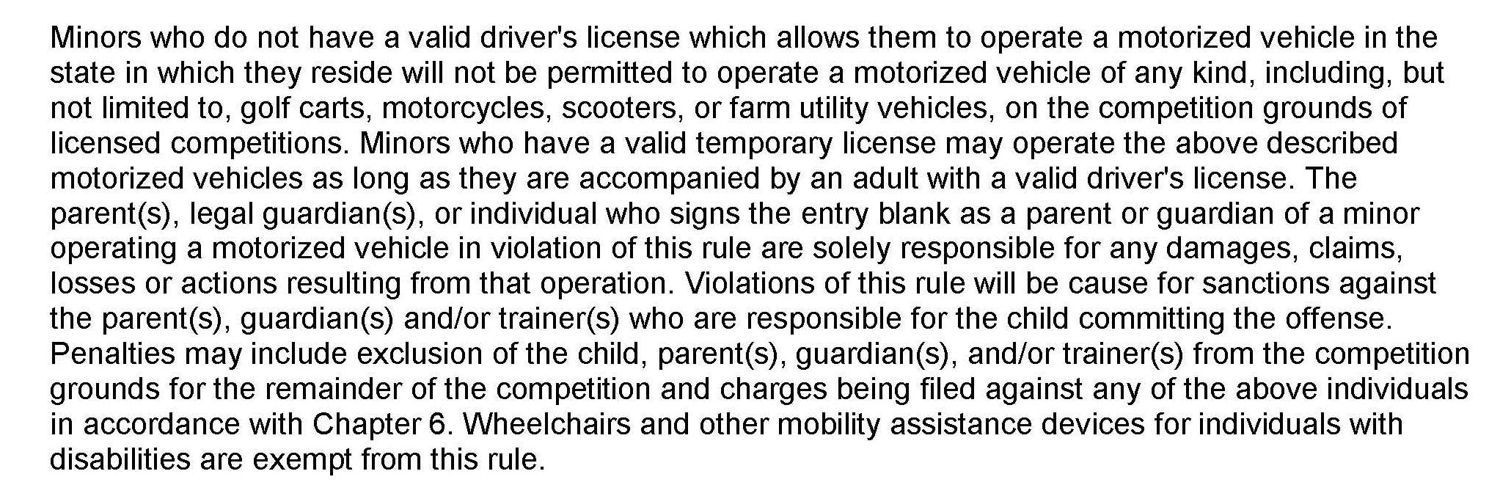

ACADEMY CLASS RULES

UPHA CHAPTER 16 ACADEMY RULES
These rules have been established by the trainers, instructors and show committees of UPHA Chapter 16.

ALL RIDERS UNDER 18 YEARS OF AGE MUST WEAR HELMETS!
The Academy Division is open only to riders who have never competed in a regular horse show in full show attire for their respective division. Riders must be competing on an Academy horse.

The Academy Horse is defined as a horse of any breed that is regularly used in a professionally operated lesson program. An Academy horse may be privately owned, however, in addition to being used in the lesson program, someone other than the horses' owner must also show it in competition. The Academy horse must display safe manners and characteristics desired of a lesson horse. A plain shod horse is required; one pad and/or therapeutic wedge is allowed. Desired is a clean, well turned out horse; hoof blacking is optional, and braiding is only allowed in the hunt seat classes. Horses are not to be judged; way of going is not to be considered.

Tack: Horses are to be tacked according to the division the rider is competing in. Instructors are encouraged to bridle their horses in a safe manner; tie downs, standing martingales or blinkers are not allowed.

Attire - For the Saddle Seat rider: jodhpurs, jodhpur boots or paddock boots, long sleeve, button-down or collared shirt, tie and gloves are required. Vests are optional, no derbies allowed.

Attire - For the Hunt seat rider: breeches, and an appropriate hunt seat shirt, hunt boots or paddock boots and gloves are required. "Polo" shirts are not allowed.

Attire - For the Western rider: appropriate western shirt, pants, tie, boots and gloves are required. Chaps or western hats are not allowed.

Class Rules: Headers are allowed in if needed for safety, no whips or towels allowed in with them. Classes will be split at the 13th rider; splits will be shuffled to keep equitation and showmanship back to back for each age group. Class holds will be 2 minutes in length. NO EXCEPTIONS.

Equitation classes are judged on the riders basic equitation skills with correct diagonals and leads to be counted; proper use of the show ring is to be considered.

Showmanship classes are judged on the rider's horsemanship abilities. They are judged on a rider's ability to control and show their horse, including speed, collectiveness and placement in the ring. In canter classes, promptness in finding the correct lead is important as well as the rider's command of the horse.

Novice classes are for riders who have not received 3 blue ribbons in the academy division.

For riders under 18, safety helmets are mandatory. For riders over 18, safety helmets are optional but strongly encouraged

Become a Show Patron!!
Show Patron includes: Preferred Stalling (your requested location, first come first serve), 4 class sponsorships, name announced throughout show, name listed on “Show Patron” display and a Patron “Daily Perk”.

SPONSORSHIP FORM

BUSINESS/FARM NAME:
NAME: PHONE
ADDRESS
CITY: STATE: ZIP:

TYPE OF SPONSORSHIP

Show Patron $225.00 x # = total
Regular Halter / Sport Horse In Hand $25.00 x # = total
Perf. / Sport Hrs Class $25.00 or 3/$60.00 x # = total
Please contact Jeff Rutz 651-792-5851 for more information

PLEASE CHECK THE TYPE OF CLASS YOU WOULD LIKE TO SPONSOR

Western Hunter Dressage____________________
English Country English Halter_____________________

Please return your ad copy and a brief message about your business or farm with this form for the announcer to read before and after your sponsored class(es). Class sponsorships will be accepted by mail until June 15, or during the shows. MHAHA and the management of the Great Arabian Get Together thank you for your patronage and support.

Make checks payable to MHAHA and send to:

Jeff Rutz
6996 2nd Avenue
Lino Lakes, MN 55014
(651) 792-5851
jjrutz45@gmail.com

STABLING REQUEST FORM

RETURN WITH ENTRIES TO:
LEESA BERHOW, N12861 190th Street, Boyceville, WI 54725

COPY OF CURRENT NEGATIVE COGGINS (12 mo. or less) MUST ACCOMPANY ENTRIES. ORIGINAL NEGATIVE COGGINS MUST BE AVAILABLE FOR INSPECTION AT THE SHOW

Detach this form and send with check payable to M.H.A.H.A. to the above address. No stalls will be reserved by phone. Straw bedding is not allowed on grounds. Shavings will be available for purchase. Show office must be notified of unused stalls. Do not rent out your stall. Trainers, if you are paying for the stalls of your clients, you must include their names on this form if they are sending in their own entries. No stalls will be assigned unless payment in full is sent with this form.

NO DOGS LEFT OVERNIGHT IN BARN!

NAME:
STABLE: (or stable with)
ADDRESS:
CITY: STATE: ZIP
PHONE: home cell

I AM REQUESTING STALLS FOR: Check all that apply
Wednesday
Thursday
Friday

I AM BRINGING: # HORSES

# Stallions # Mares # Geldings # Foals

FEES: Transfer totals to entry form

# Box Stalls x $ 60/Night = $
# Tack Stalls x $65/N $100/show $
# Bags of Shaving x $12.00 = $
(Additional bags of shaving can be purchased in the show office)

GAGT Class Schedule

Thursday - 9:00 AM

Class Number Class Code Class name
1 225 Arabian Reining Open
2 660 HA/AA Reining Open
3 230 Arabian Reining ATR
4 665 HA/AA Reining ATR
5 234 Arabian Reining Jr Horse
6 668 HA/AA Reining Jr Horse
7 931 AHA Reining Seat Medal
8 Schooling Western Pleasure
9 Schooling Hunter/Saddle Seat Pleasure
10 Schooling Ranch Rail
11 733+ HA/AA Hunt Pl Open
12 1936+ Arabian Western Pl Open
13 590 HA/AA Native Costume
14 2344 HA/AA Ranch Rail
15 TBA
16 290+ Arabian Hunt Pl Open
17 150 Arabian Native Costume
18 Arabian Hunt Pl JTR
19 204++ Arabian Western Pl Jr Horse
20 636++ HA/AA Western Pl Jr Horse
21 735+ HA/AA Hunt Pl AOTS
22 620+ HA/AA Western Pl Open
23 556++ HA/AA Country English Pl Jr Horse
24 190+ Arabian Western Pl ATR Select
25 xxx Arabian Hunt Pl. AOTR
26 90++ Arabian English Pl Jr Horse
27 HA/AA Hunt Pl AATR
28 95+ Arabian Country English Pl Open
29 531++ HA/AA English Pl Jr Horse
30 Saddle Seat Equitation ATR
31 622+ HA/AA Western Pl AOTS
32 292+ Arabian Hunter Pl AOTS
33 Schooling Jr Horse Any Seat

Thursday - Not Before 11:00 AM

34 991 Lead Line 6&U
35 1733 Arabian Ranch Rail
36 TBA
37 1326+ Arabian Hunt Pl AATR
38 890 W/T Hunt/Saddle Seat Pl 10&U
39 1338+ HA/AA Hunter Pl JTR
40 Arabian Country English Pl ATR Select
41 540+ HA/AA Country English Pl Open
42 208 Arabian Western Pl AATR
43 xxxx HA/AA Western Pl. AOTR
44 TBA
45 xxxx Arabian Country Pl. AOTR
46 299+ Arabian Hunter Pl ATR
47 2350 HA/AA Ranch Rail Jr Horse
48 907 W/T Western Pl 10&U
49 741+ HA/AA Hunter Pl ATR
50 xxxx Arabian Western Pl. AOTR
51 JACKPOT AHA Saddle Seat Pl ATR Jackpot
52 TBA
53 3136+ HA/AA Western Pl ATR Select
54 xxxx HA/AA Hunt Pl. AOTR
55 515+ HA/AA English Pl Open
56 xxxx HA/AA Country Pl. AOTR
57 JACKPOT AHA Western Pleasure ATR Jackpot
58 938 AHA Hunt Seat Equitation Medal JTR
59 TBA
60 TBA
61 Bareback Equitation
62 Tandem Bareback
63 Stick Horse

Thursday - Not Before 3:00 PM

66 TBA
67 JACKPOT AHA Hunter Pl ATR Jackpot
68 1739 Arabian Ranch Rail Jr Horse
69 HA/AA Western Pl JTR
70 956 UPHA Challenge Cup 13&U
71 956 UPHA Challenge Cup 14-17
72 754 HA/AA Show Hack
73 748++ HA/AA Hunter Pl Jr Horse
74 104+ Arabian Country English Pl ATR
75 192+ Arabian Western Pl AOTS
76 524++ HA/AA English Pl ATR
77 HA/AA Western Pl AATR
78 AHA Western Pl W/J 19&U
79 305++ Arabian Hunter Pl Jr Horse
80 HA/AA Country English Pl ATR Select
81 75+ Arabian English Pl Open
82 TBA

Short Break - Trail Setup

83 691 HA/AA English Trail
84 179 Arabian English Trail
85 645 HA/AA Trail Novice Horse
86 210 Arabian Trail Novice Horse
87 645 HA/AA Trail
88 210 Arabian Trail
89 651 HA/AA Trail ATR
90 216 Arabian Trail ATR
91 AHA W/T Trail - Any Age
92 Schooling Ranch Riding
93 3026 HA/AA Ranch Horse Riding
94 3006 Arabian Ranch Horse Riding
95 3028 HA/AA Ranch Horse Riding ATR
96 3008 Arabian Ranch Horse Riding ATR
97 3022 Arabian Ranch Horse Riding Jr Horse
98 3037 HA/AA Ranch Horse Riding Jr Horse
99 TBA

Friday - 8:00 AM

100 918 Showmanship 19&U
101 918 Showmanship 15-18
102 1371 Showmanship 14&U
103 1512 Arabian Performance Halter Mares
104 2078 Arabian Performance Halter Geldings
105 2018 Arabian Performance Halter Stallions
106 1446 HA/AA Performance Halter Geldings
107 1156 HA/AA Performance Halter Mares
108 TBA
109 Schooling Any Seat
110 1735 Arabian Ranch Rail ATR
111 733+ HA/AA Hunt Pl Novice Horse
112 549++ HA/AA Country English Pl ATR
113 629 HA/AA Western Pl ATR
114 83++ Arabian English Pl ATR
115 190+ Arabian Western Pl Novice Horse
116 111++ Arabian Country English Pl Jr Horse
117 113 Arabian Show Hack
118 198+ Arabian Western Pl ATR
119 2946+ HA/AA Hunter Pl ATR Select
120 AHA Western Horsemanship ATR
121 290+ Arabian Hunter Pl Novice Horse
122 939 AHA Hunt Seat Equitation ATR
123 950 AHA Western Horsemanship Medal
124 620+ HA/AA Western Pl Novice Horse
125 932 W/T Western Seat Equitation 10&U
126 924 AHA Saddle Seat Equitation Medal
127 2236+ Arabian Hunter Pl ATR Select
128 2346 HA/AA Ranch Rail ATR
129 1327+ Arabian Western Pl JTR
130 907 W/T Hunt/Saddle Seat Equitation 10&U

Friday - Time TBD

131 891 W/T Western Pl Championship
132 199 Arabian Western Pl ATR Championship
133 105 Arabian Country Pl ATR Championship
134 300 Arabian Hunter Pl ATR Championship
135 Arabian Ranch Rail ATR Championship
136 891 W/T Hunt/Saddle Seat Championship
137 630 HA/AA Western Pl ATR Championship
138 742 HA/AA Hunter Pl ATR Championship
139 HA/AA Country English Pl ATR Championship
140 HA/AA Ranch Rail ATR Championship
141 TBA - Open Championship Only

FRIDAY EVENING – Not before 4 PM.
Outdoor Grass Area.
SPORT HORSE IN-HAND
Class AHA
No Code Class Description

SH1 2760 Arab Fillies/Mares Dressage Type – Open
SH2 39 SH Arab Mares 2 & Over - Open
SH3 2708 SH Arab Fillies & Mares Dressage Type – ATH
SH4 2700 SH Arab Fillies & Mares Hunter Type – Open
SH5 2768 SH Arab Fillies & Mares Hunter Type ATH
SH6 43 SH Arabian Mares 2 & over – ATH
SH7 2800 SH Arabian Geldings Dressage Type – Open
SH8 53 SH Arab Geldings 2 & Over – Open
SH9 2808 SH Arab Geldings Dressage Type – ATH
SH10 2 740 SH Arabian Geldings Hunter Type – Open
SH11 2748 SH Arab Geldings Hunter Type ATH
SH12 57 SH Arab Geldings 2 & over - ATH
SH13 2780 SH Arab Colts & Stallions Dressage Type – Open
SH14 2720 SH Arab Colts & Stallions Hunter Type - Open
SH15 50 SH Arab Stallions 2 & over - ATH
SH16 2880 SH HA Fillies & Mares Dressage Type – Open
SH17 475 SH HA Mares 2 & Over – Open
SH18 2888 SH HA Fillies & Mares Dressage Type – ATH
SH19 2820 SH HA Fillies & Mares Hunter Type – Open
SH20 2828 SH HA Fillies & Mares Hunter Type ATH
SH21 479 SH HA Mares 2 & over - ATH
SH22 2920 SH HA Geldings Dressage Type – Open
SH23 494 SH HA Geldings 2 & Over – Open
SH24 2928 SH HA Geldings Dressage Type – ATH
SH25 2860 SH HA Geldings Hunter Type – Open
SH26 2868 SH HA Geldings Hunter Type ATH
SH27 498 SH HA Geldings 2 & over - ATH
SH28 2900 SH HA Colts & Stallions Dressage Type – Open
SH29 2840 SH HA Colts & Stallions Hunter Type – Open
SH30 2908 SH HA Stallions 2 & Over – ATH -

SPORT HORSE UNDER SADDLE – Indoor Arena

SH 31 AHA Dressage Seat Medal Class
SH 32 Arabian SH Under Saddle – Dressage Type - Open
SH 33 Arabian SH Under Saddle – ATR
SH 34 Arabian SH Show Hack – Open
SH 35 HA SH Under Saddle – Dressage Type - Open
SH 36 HA SH Under Saddle – ATR
SH 37 HA SH Show Hack - Open
SH 38 Arabian SH Under Saddle – Hunter Type - Open
SH 39 HA SH Under Saddle – Hunter Type – Open

Saturday – 9:00 AM Academy Classes
142. Academy Showmanship Halter
143. Academy Saddleseat English PL W/T/C
144. Academy Saddleseat Equitation W/T/C
145. Academy Hunter PL W/T/C
146. Academy Saddleseat English PL W/T
147. Academy Huntseat Equitation W/T/C
148 Academy Western PM W/J/L
149. Academy Western Equitation W/J/L
150 Academy Hunter PL W/T
151 Academy Western PL W/J
152 Academy Western Equitation W/J
153 Academy Huntseat Equitation W/T
154 Academy Walk Only Pattern
155. TBA Academy Only

